**Multi-threaded Socket-based Chatbot**

**Project Report**



**Spring 2023**

**CSE-204L Operating Systems Lab**

Submitted by:

**Shahzad Bangash(21PWCSE1980)**

**Suleman Shah(21PWCSE1983)**

**Ali Asghar(21PWCSE2059)**

Class Section: **C**

“On my honor, as student of University of Engineering and Technology, I have neither given nor received unauthorized assistance on this academic work.”

Submitted to:

**Engr. Madiha Sher**

Date:

**July 9, 2023**

**Department of Computer Systems Engineering**

**University of Engineering and Technology, Peshawar**

**Problem Statement:**

The problem addressed by this project is to develop a socket-based chatbot application that allows clients to communicate with a server and retrieve summarized information from Wikipedia. The goal is to enable users to send messages to the server and receive concise summaries of the corresponding Wikipedia articles in real-time.

**Introduction:**

The project is a simple chatbot application that uses socket programming to establish communication between a client and a server. The server receives messages from the client, processes them, and retrieves a summary of the corresponding topic from Wikipedia. The server then sends the summary back to the client for display.

**Methodology:**

The project methodology comprises the following steps:

**Code Screenshots:**

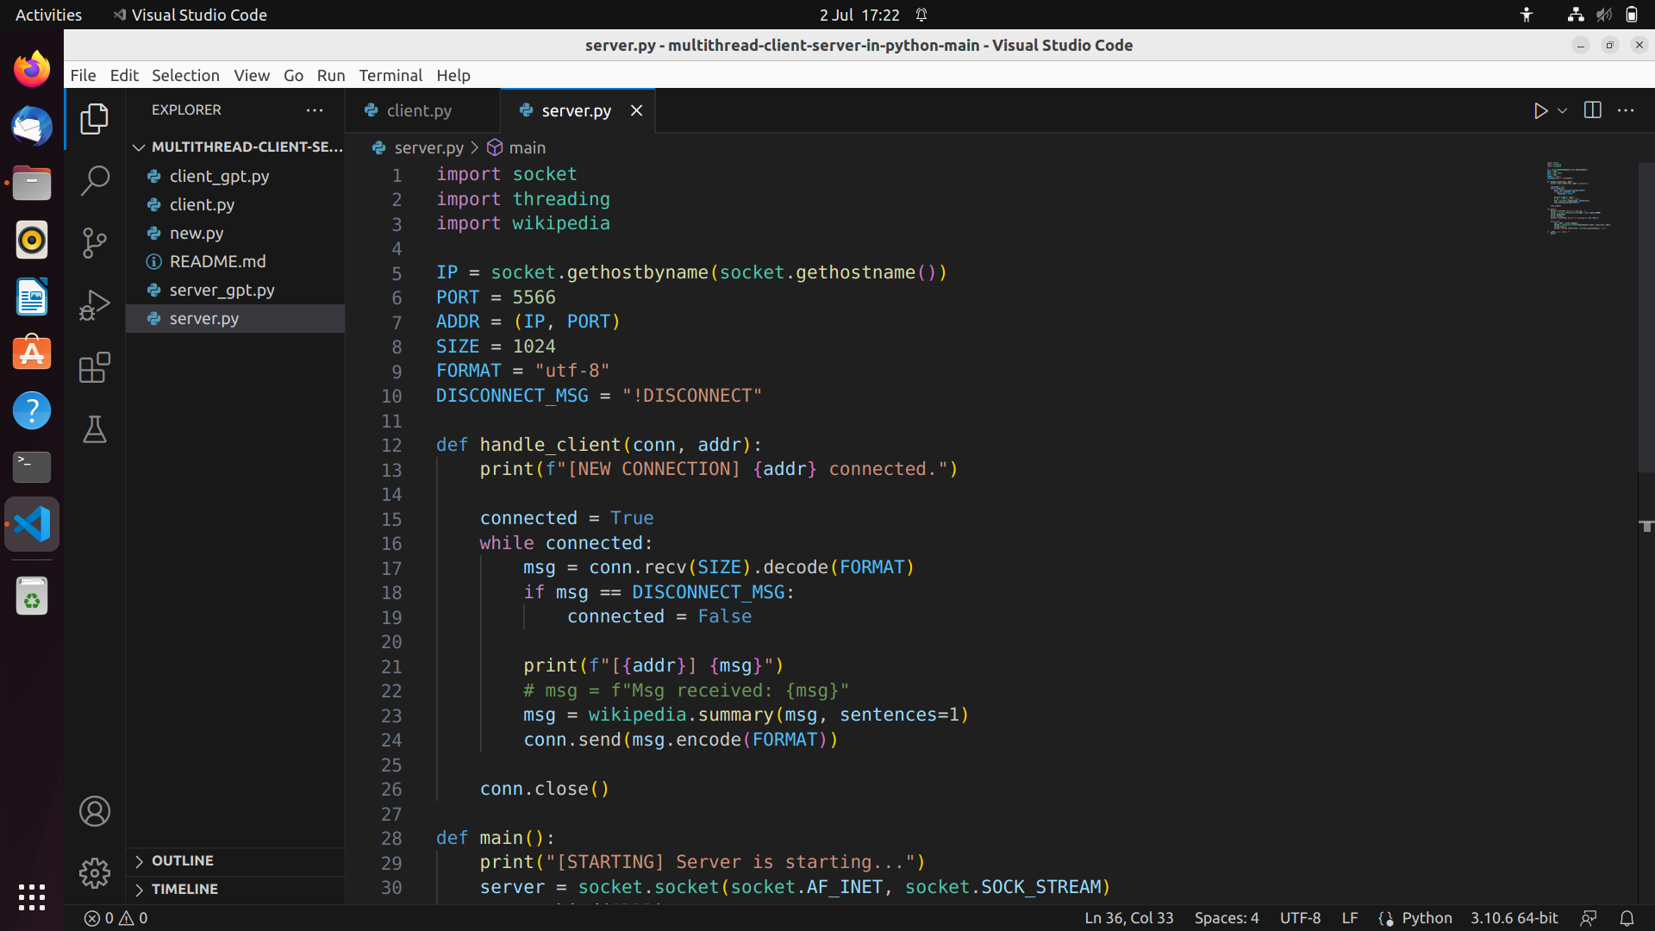

Figure 1-1a: Python Code for Server Implementation

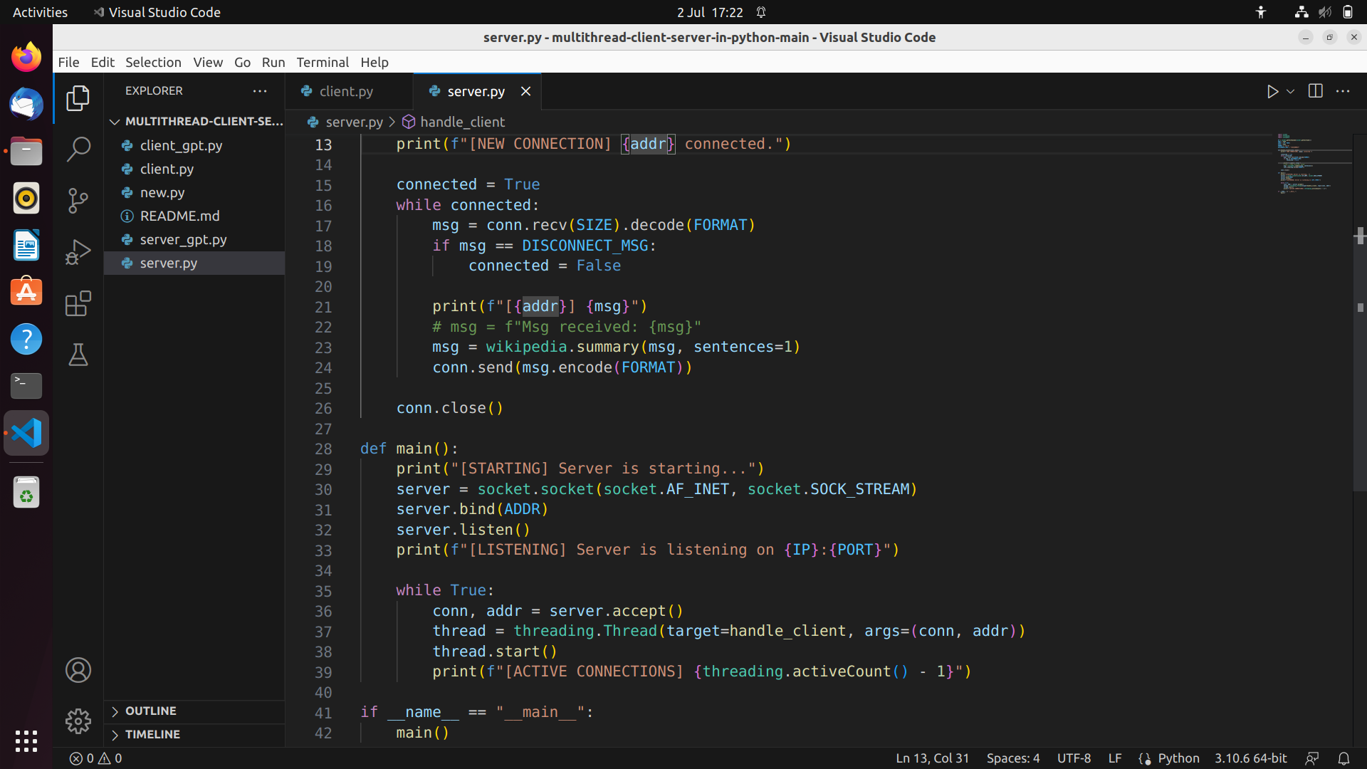

Figure 1-1b: Python Code for Server Implementation(Remaining Part)

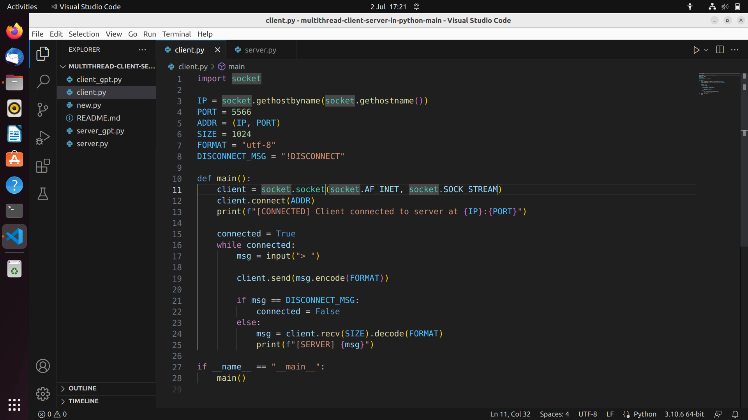

Figure 1-2: Python Code for Client Implementation

**Code Explanation:**

**Server:**

The above lines of code initialize and assign values to important variables used in a client-server chatbot application. The **IP** variable retrieves the IP address of the host machine, while the **PORT** variable defines the port number for communication. The **ADDR** variable combines the IP address and port number into a tuple, representing the server address. The **SIZE** variable sets the maximum size of messages that can be sent or received. The **FORMAT** variable specifies the character encoding format for message encoding and decoding. Finally, the **DISCONNECT_MSG** variable defines a specific message indicating the client's intention to disconnect from the server. These variables play a crucial role in configuring and establishing communication between the client and server in the chatbot application.

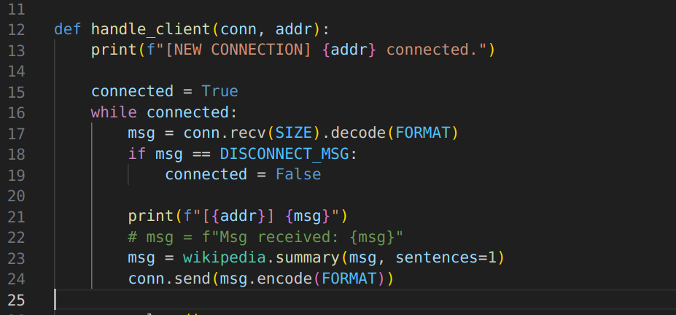

**handle_client** function is responsible for managing communication with a connected client in the server-side code. It receives messages from the client, checks if the client wants to disconnect, prints the received message and client's address, retrieves a summary of the message from Wikipedia, and sends the summary back to the client. This function continues to run as long as the client remains connected, and it closes the connection once the client decides to disconnect.

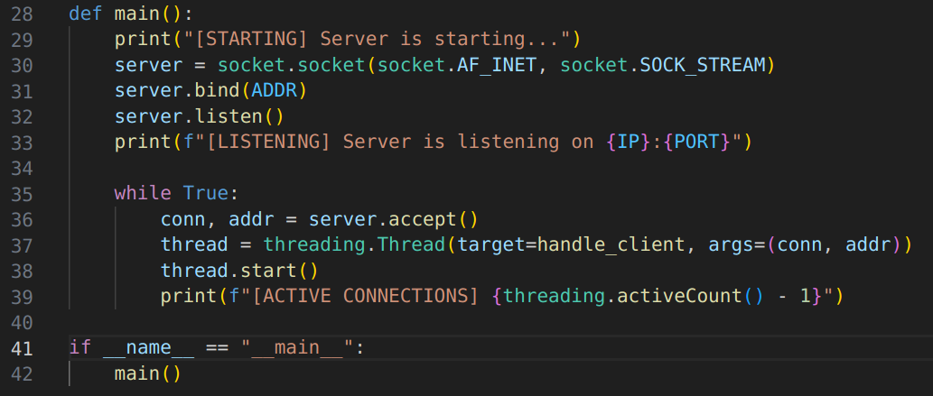

The **main** function in the server-side code is responsible for setting up the server, listening for incoming client connections, and spawning new threads to handle each client. It creates a server socket, binds it to the specified IP address and port, and enters a continuous loop to accept connections. For each connection, it accepts the client, starts a new thread to handle communication with that client, and keeps track of the active connections. The function continuously runs until the program is terminated, allowing the server to handle multiple client connections concurrently.

**Client:**

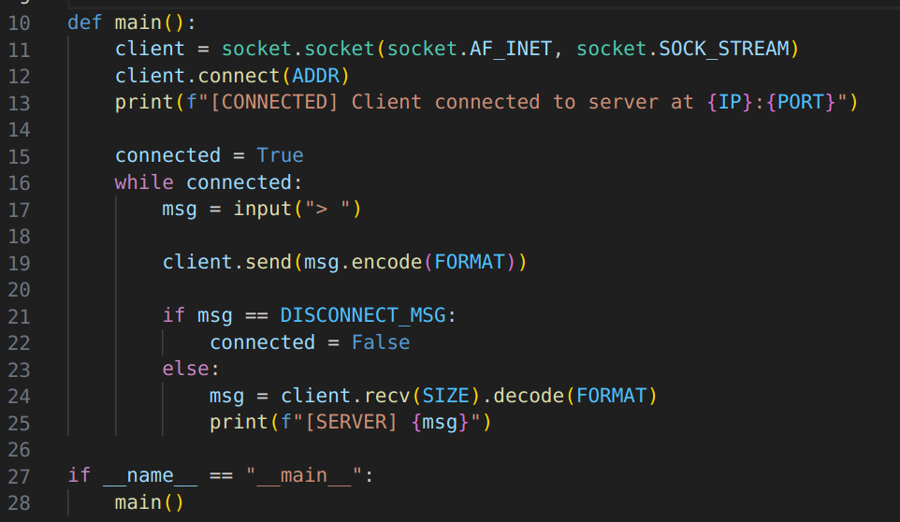

The **main** function in the client-side code establishes a connection with the server, allows the user to input messages, sends those messages to the server, and displays the server's responses. It continues to run until the client initiates a disconnection by sending a predefined disconnect message. This function forms the core of the client-side code, facilitating the interaction between the client and the server in a chat-like manner.

**Modules/Libraries Used:**

Here are the key libraries used:

**Socket:**

The socket library provides the necessary classes and methods for creating and managing socket connections. It enables communication between the client and server by establishing network connections and sending/receiving data over the network.

**Threading:**

The threading library is used to create and manage multiple threads within the server. Each thread handles communication with a specific client, allowing concurrent processing of multiple client requests.

**Wikipedia:**

The wikipedia library is used to retrieve information from Wikipedia. It provides a convenient interface to query and retrieve articles, summaries, and other details from the Wikipedia database. In this project, it is used to generate summarized information based on user queries.

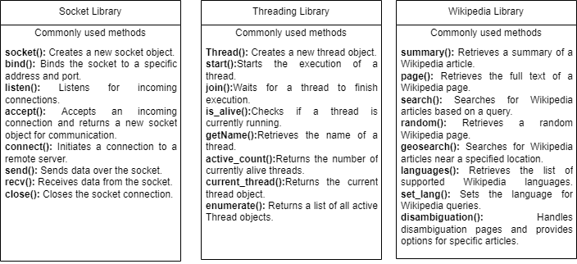

Figure 2-1: UML Diagram of Libraries Used

**Flow of Program:**

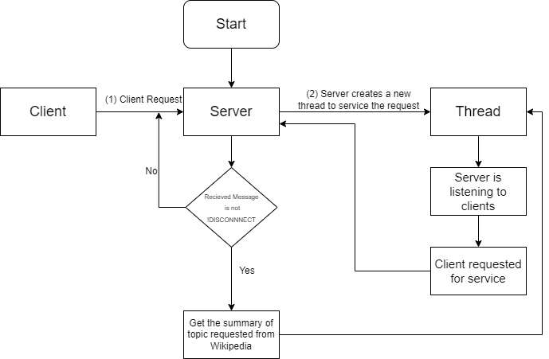

Figure 3-1: Working Flow Chart of this project

**How to Use:**

To use the chatbot application:

* + Run the server script on a machine accessible on the network.
  + Run the client script on a different machine, providing the server's IP address and port.
  + Enter queries or messages in the client console.
  + The server will retrieve the summary from Wikipedia and send it back to the client.
  + The client will display the summary in its console.
  + To disconnect, enter the predefined **!DISCONNECT** message.

**Results:**

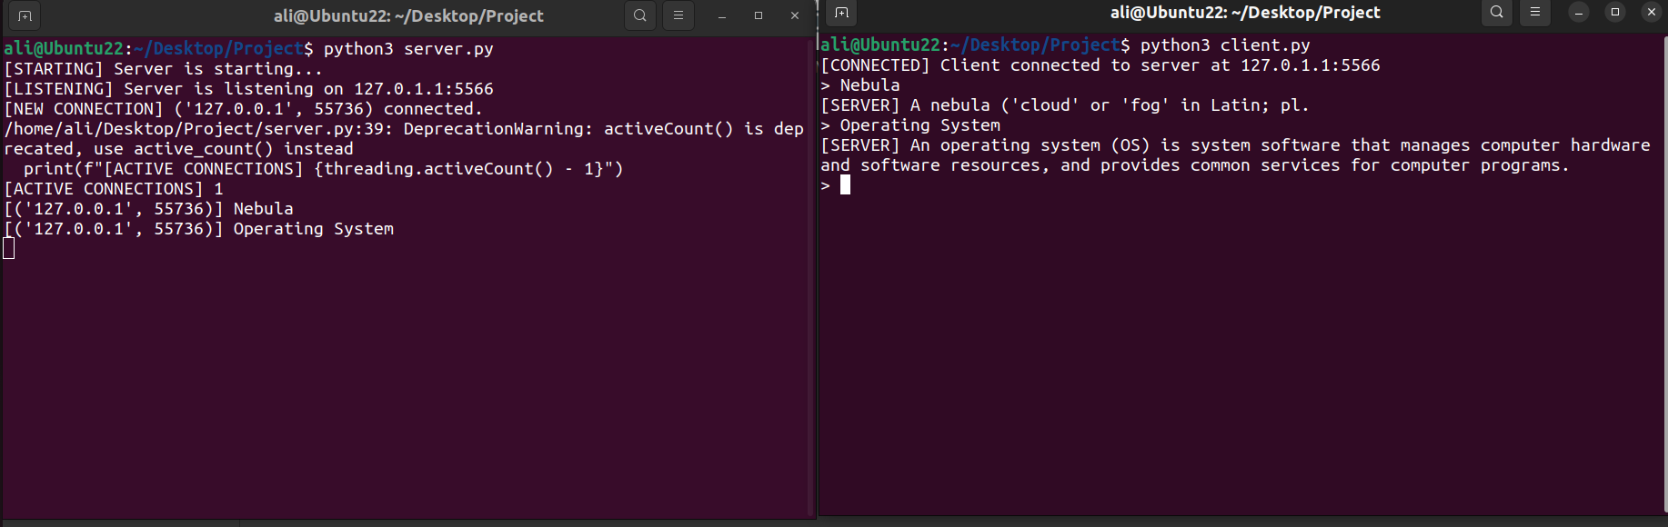



**Conclusion:**

The project demonstrates the use of socket programming to create a simple chatbot that retrieves information from Wikipedia. While it is a basic implementation, it provides a foundation for building more sophisticated chatbot applications. The project can be extended by integrating additional natural language processing capabilities, improving the user interface, and enhancing security measures.

**References:**

Abraham Silberschatz Operating System Concepts 10th Edition

<https://github.com/nikhilroxtomar/multithread-client-server-in-python>

https://www.geeksforgeeks.org/socket-programming-python